Introduction

Report (60%)

• Introduction (10%):

Introduce the concept of sorting and sorting algorithms

discuss the relevance of concepts such as complexity (time and space)
performance
in-place sorting
stable sorting
comparator functions
comparison-based
non-comparison-based sorts

• Sorting Algorithms (5 x 5 = 25%):

Introduce each of your chosen algorithms in turn,
discuss their space and time complexity, and
explain how each algorithm works using your own bespoke diagrams
different example input instances.
If you diagrams are not original creations you will get zero.

1. A simple comparison-based sort (Bubble Sort, Selection Sort or Insertion Sort)

2. An efficient comparison-based sort (Merge Sort, Quicksort or Heap Sort)

3. A non-comparison sort (Counting Sort, Bucket Sort or Radix Sort)

4. Any other sorting algorithm of your choice

5. Any other sorting algorithm of your choice

• Implementation & Benchmarking (25%):
This section will describe the process followed when implementing the application
present the results of your benchmarking.
Discuss how the measured performance of the algorithms differed
were the results similar to what you would expect
given the time complexity of each chosen algorithm?
In this section you should use both a table and a graph to summarise the results obtained
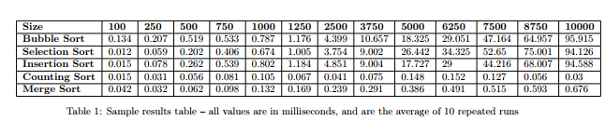

This application should include implementations of the five sorting algorithms, along with a main method which tests each of them.

Note that it is fine to reuse or adapt code for sorting algorithms from books, online resources or the lecture notes, as long as you add your own comments to the code, and acknowledge the source.

To benchmark the algorithms, you should use arrays of randomly generated integers with different input sizes n. You should use a variety of different input sizes, e.g. n=10,n=100,n=500,. . . ,n=10,000 etc. to test the effect of the input size on the running time of each algorithm. See the console output in Figure 1 for a selection of suggested sizes of n. You may test values of n which are higher than 10,000 if you wish, e.g. 500,000. Just be aware that algorithms such as Bubble Sort may take a long time to run when using large values of n!

The running time (in milliseconds) for each algorithm should be measured 10 times, and the average of the 10 runs for each algorithm and each input size n should be output to the console when the program finishes executing. See sample console output in Figure 1 (note that the output is formatted to 3 decimal places and laid out neatly):

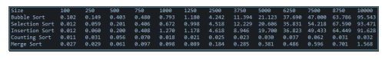
The application will be graded as follows:
• Code Quality (10%)
• Commenting (10%)
• Elegance & efficiency of bench-marking approach (20%)

1.2.2 Python
To measure the running time of a sorting algorithm, you should use Python’s time module (https://docs.python.org/3/library/time.html) to record the start and end times in milliseconds, then subtract them to obtain the running time, as per the following code sample:

start_time = time.time ()
# call your function
end_time = time.time ()
time_elapsed = end_time – start_time

The following code sample below may be useful { the function random array() takes as input a value n and returns an array of n randomly generated integers with values between 0 and 99. You may use this code to generate random input instances which can be used when benchmarking your chosen sorting algorithms. Note you must import randint from Python’s random module (https://docs.python.org/3/library/random.html) to use this code sample.

def random_array (n):
array = []
for i in range (0, n, 1):
array.append (randint (0, 100) )
return array

